MODULE 1:
- This module involves downloading data and uploading it to MATLAB. The data was downloaded from Kaggle in CSV format.
- DATA CONTENT: Historical Data of the stock market of NVIDIA
- LINK: https://www.kaggle.com/code/furkan09/nvidia-stocks-analysis/input

Loading Data on MATLAB:
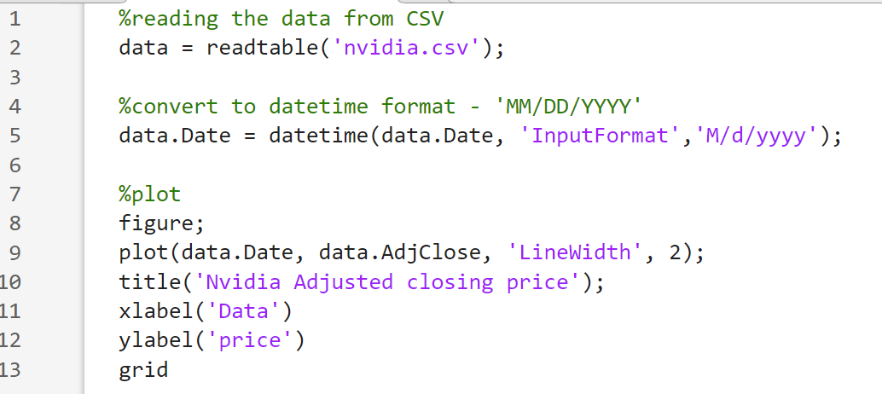

Output:
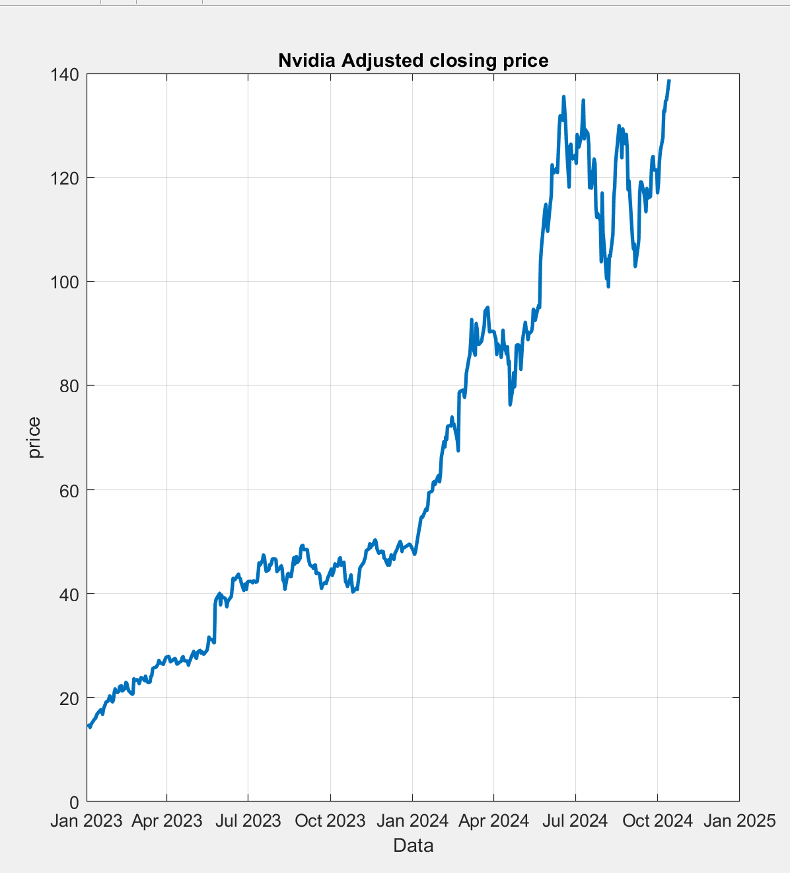
Code Explanation:
data = readtable('nvidia.csv');
Reads the data from CSV
data.Date = datetime(data.Date, 'InputFormat', 'M/d/yyyy') => Here we are defining the format based on our CSV file for good practice.
- data.Date: This refers to the column named Date in the table data. When we use the dot operator, we're accessing the actual content in that column (which is a datetime array).
- he datetime function is used to convert date and time information into MATLAB's datetime object. This object represents dates and times in a way that MATLAB can process and perform calculations on easily (e.g., time differences, formatting, etc.).
- Syntax: t = datetime(Year, Month, Day)
- • Year: A number representing the year (e.g., 2023).
- • Month: A number representing the month (1 to 12).
- • Day: A number representing the day (1 to 31).
plot(data.Date, data.AdjClose, 'LineWidth', 1.5);
- data.Date
- This is the X-axis in the plot, representing the dates of each stock price point.
- data.Date is a datetime array containing the dates (like 1/3/2023, 1/4/2023, etc.).
- MATLAB automatically formats and labels the X-axis based on the datetime values, so it will show each date along the bottom axis.

data.AdjClose
- This is the Y-axis in the plot, representing the stock prices (adjusted closing prices).
- data.AdjClose is an array of numerical values — these are the stock prices for each corresponding date in data.Date.
- When you pass this to the plot() function, it tells MATLAB to plot these values on the vertical axis (Y-axis).

MODULE 2:

Wavelet Analysis of the DATA:
Wavelet transforms are often used in signal processing because they can break down a signal into components at different scales (i.e., different frequencies) while preserving the signal's time aspect.
This is particularly useful for non-stationary data, like stock prices, where frequency components might change over time.
In MATLAB, the most common approach to performing wavelet analysis is to use Continuous Wavelet Transform (CWT).
Why Wavelets?
- Time-frequency analysis: Unlike the Fourier Transform, which only gives frequency information, wavelets provide both time and frequency information.
- Multiresolution: Wavelets allow you to examine the signal at different scales (i.e., zoom in and out on the data).
- Handling non-stationary signals: Wavelet transforms can handle signals whose frequency characteristics change over time (e.g., stock prices).

Applying Absolute wavelet Transform:
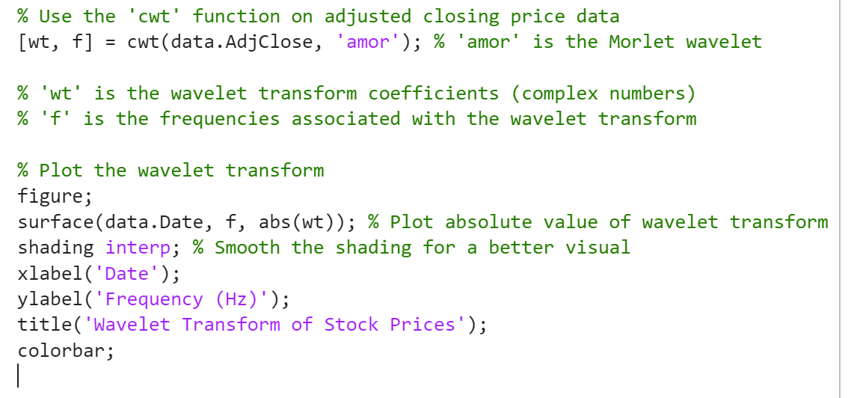

Output:

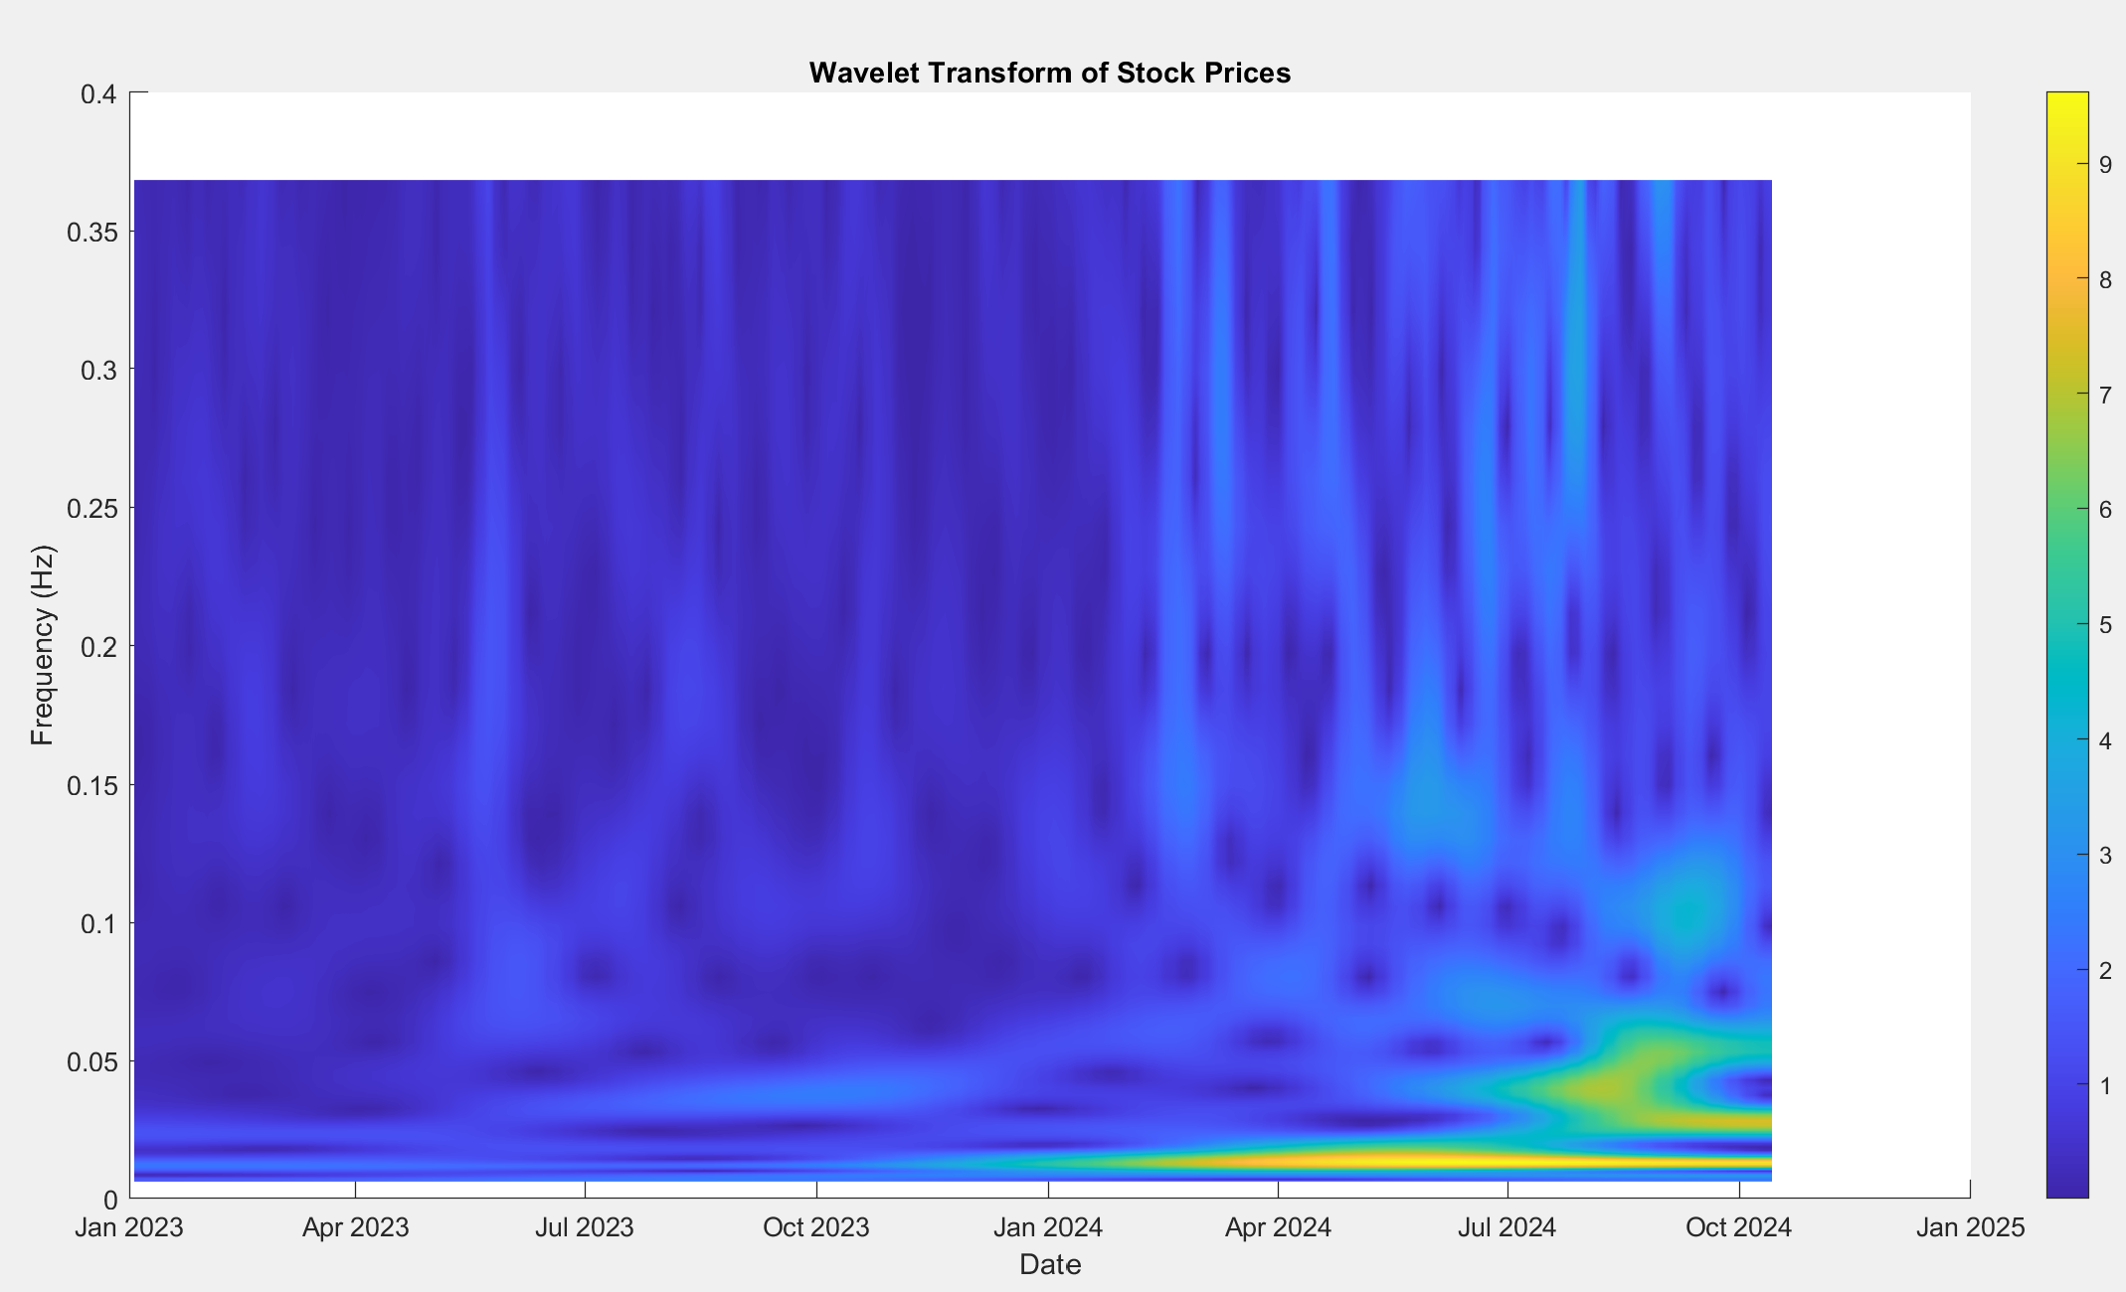

Code Explanation:
What is [wt, f] = cwt(data.AdjClose, 'amor')?
This line performs a continuous wavelet Transform (CWT) on our signal using ‘amor’ (MORLET) wavelet.
- wt: A matrix of complex wavelet coefficients.
- f: A vector containing the frequencies corresponding to each row of wt.
What Does This Mean?
Imagine your signal (data.AdjClose) has T time points. When you apply cwt:
- It analyzes each frequency over all time points.
- So you get a matrix wt where:
  - Rows represent frequencies
  - Columns represent time
- • wt(i, j) = Wavelet coefficient at the i-th frequency and j-th time point
- • f(i) = Frequency corresponding to the i-th row of wt
The 'amor' Wavelet:
- 'amor' stands for analytic Morlet wavelet.
- It’s ideal for analyzing oscillatory signals like stock prices.
- It gives good time-frequency localization — letting you see both short- and long-term patterns.

Morlet Wavelet: The Morlet wavelet (or Gabor wavelet) is essentially a sine wave that is localized by a Gaussian envelope.
A smooth oscillation (like a sine wave), but only for a short time. Then it fades away. That’s the Morlet wavelet.
Why Use Morlet?
- Great for detecting oscillatory behavior.
- Excellent time-frequency localization:
  - You get to know when something happened and at what frequency.
- Very useful when you're analyzing non-stationary signals, like stock prices that fluctuate unpredictably.
📈 Morlet in Financial Time Series:
- Can help detect volatility clusters.
- Uncover cyclical trends or market shocks over time.
- Ideal when you need to analyze both frequency and time domains simultaneously.
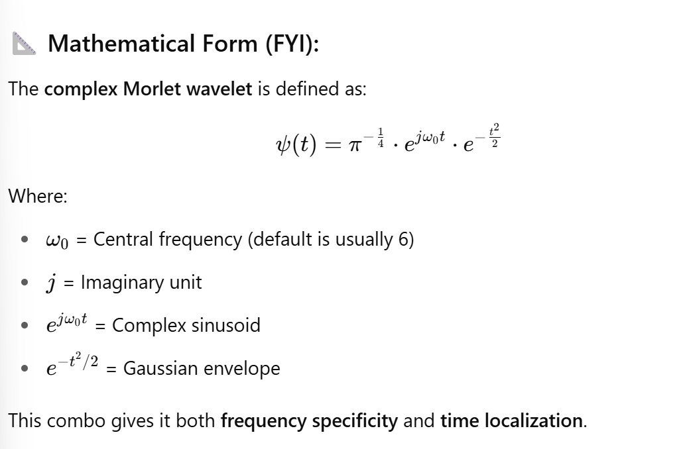

surface(data.Date, f, abs(wt));
This is creating a 3D surface plot of the wavelet transform output.
- Data.Date -> Time axis (x-axis)
- f-> Frequency axis (y-axis)
- abs(wt) ->magnitude of complex wavelet coefficient (z-axis/color)

abs(wt)
• The wavelet transform wt is complex (has real and imaginary parts).
• abs(wt) gives the magnitude, which tells you the intensity/power of a feature at that time and frequency
shading interp
This line smooths out the surface plot.
- shading controls how color is applied between grid points.
- interp = interpolated shading, which blends the colors between grid points.
Without it, you'd get a blocky, pixelated surface. With shading interp, the surface looks smooth and continuous.
colorbar;
This simply adds a color scale legend to your plot.
- It shows the mapping between colors and values (i.e., the magnitude of the wavelet coefficients).
- The more intense the color (e.g., yellow/red), the stronger the frequency component at that point in time.

MODULE 3:

ANALYZE Specific Time-Frequency Regions:
We’ll start by zooming into a frequency range or a time period that might show interesting features.

